**Results**

**Years Experience v. Pitch Score**

**Bayesian Correlation Pairs**

| **Bayesian Pearson Correlation** | | | | | | | | | | | | | |
| --- | --- | --- | --- | --- | --- | --- | --- | --- | --- | --- | --- | --- | --- |
|  | | | | | | | | | | **95% Credible interval** | | | |
|  | |  | |  | | **r** | | **BF₊₀** | | **Lower** | | **Upper** | |
| YearsExperience |  | - |  | PitchScore |  | 0.301 |  | 49.205 |  | 0.125 |  | 0.453 |  |
|  | | | | | | | | | | | | | |
| *Note* . For all tests, the alternative hypothesis specifies that the correlation is positive. | | | | | | | | | | | | | |

**Plots**

**YearsExperience - PitchScore**

**Scatterplot**

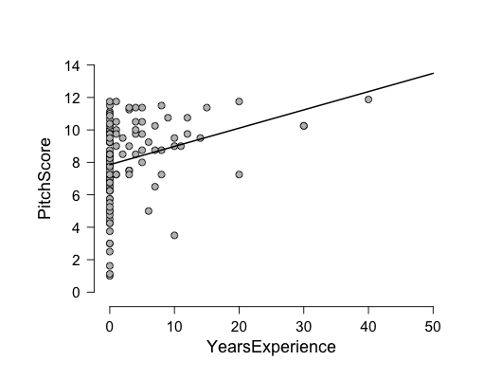

**Prior and Posterior**

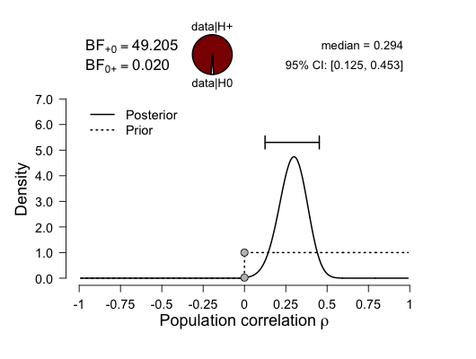

**Bayes Factor Robustness Check**

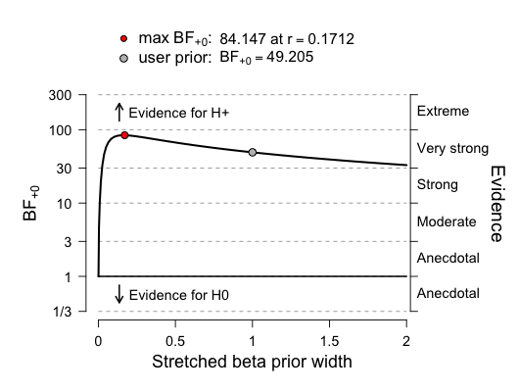

**Sequential Analysis**

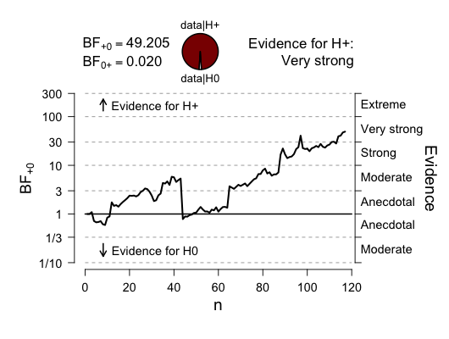

**Results**

**Years Experience by Emotion ID Score**

**Bayesian Correlation Pairs**

| **Bayesian Pearson Correlation** | | | | | | | | | | | | | |
| --- | --- | --- | --- | --- | --- | --- | --- | --- | --- | --- | --- | --- | --- |
|  | | | | | | | | | | **95% Credible interval** | | | |
|  | |  | |  | | **r** | | **BF₊₀** | | **Lower** | | **Upper** | |
| YearsExperience |  | - |  | EmotionIDScore |  | -0.090 |  | 0.062 |  | 0.002 |  | 0.153 |  |
|  | | | | | | | | | | | | | |
| *Note* . For all tests, the alternative hypothesis specifies that the correlation is positive. | | | | | | | | | | | | | |

**Plots**

**YearsExperience - EmotionIDScore**

**Scatterplot**

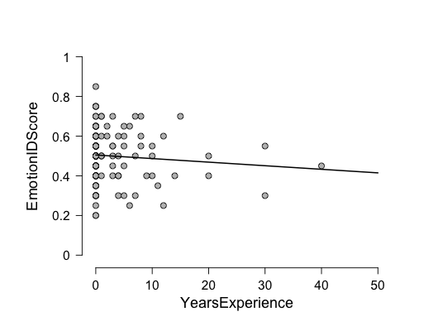

**Prior and Posterior**

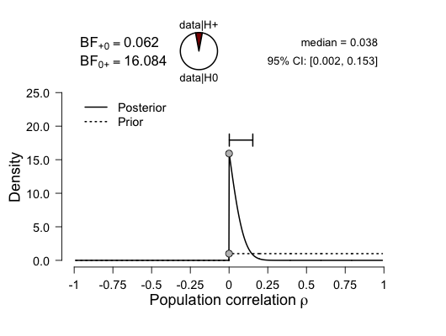

**Bayes Factor Robustness Check**

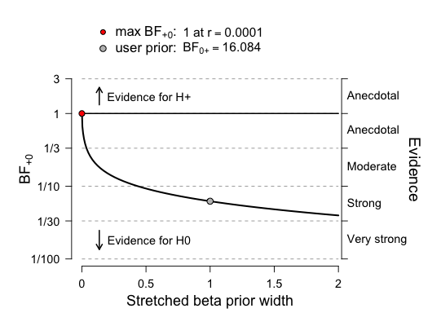

**Sequential Analysis**

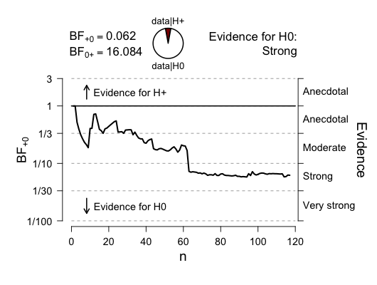

**Results**

**Bayesian Correlation Pairs**

| **Bayesian Pearson Correlation** | | | | | | | | | | | | | |
| --- | --- | --- | --- | --- | --- | --- | --- | --- | --- | --- | --- | --- | --- |
|  | | | | | | | | | | **95% Credible interval** | | | |
|  | |  | |  | | **r** | | **BF₊₀** | | **Lower** | | **Upper** | |
| PitchScore |  | - |  | EmotionIDScore |  | 0.081 |  | 0.271 |  | 0.007 |  | 0.264 |  |
|  | | | | | | | | | | | | | |
| *Note* . For all tests, the alternative hypothesis specifies that the correlation is positive. | | | | | | | | | | | | | |

**Plots**

**PitchScore - EmotionIDScore**

**Scatterplot**

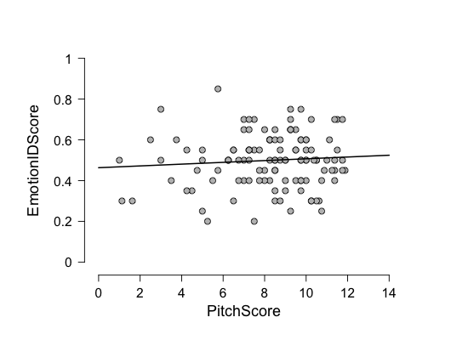

**Prior and Posterior**

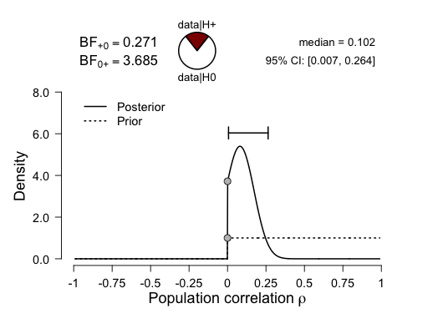

**Bayes Factor Robustness Check**

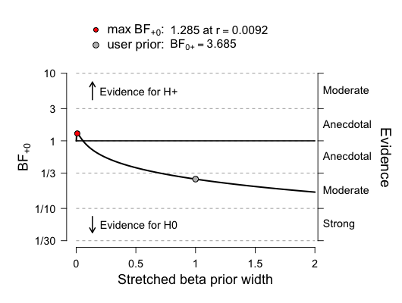

**Sequential Analysis**

